Theme: Visit our stand at Woodex 2023, Moscow
Our company ____________________________ invites you to visit our stand no. __ in pavilion 1, hall____, at Woodex 2023 - 18th International exhibition of equipment, materials and components for the woodworking and furniture industry.

Exhibition dates: 28 November – 1 December, 2023
Location: Russia, Moscow, Crocus Expo IEC, pavilion 1

Our representatives will be glad to see you at the stand and give you information and advice about the products [list of names] produced by [name of organization/brand].
Our company will present:
-
-
For free registration please use a promo code: _______ on the exhibition website https://woodexpo.ru/en/visit/visitor-registration/
Get your personal badge for the exhibitions now with only a few clicks and thus save time at the show.
About Woodex exhibition>>
More information about exhibition sectors>>
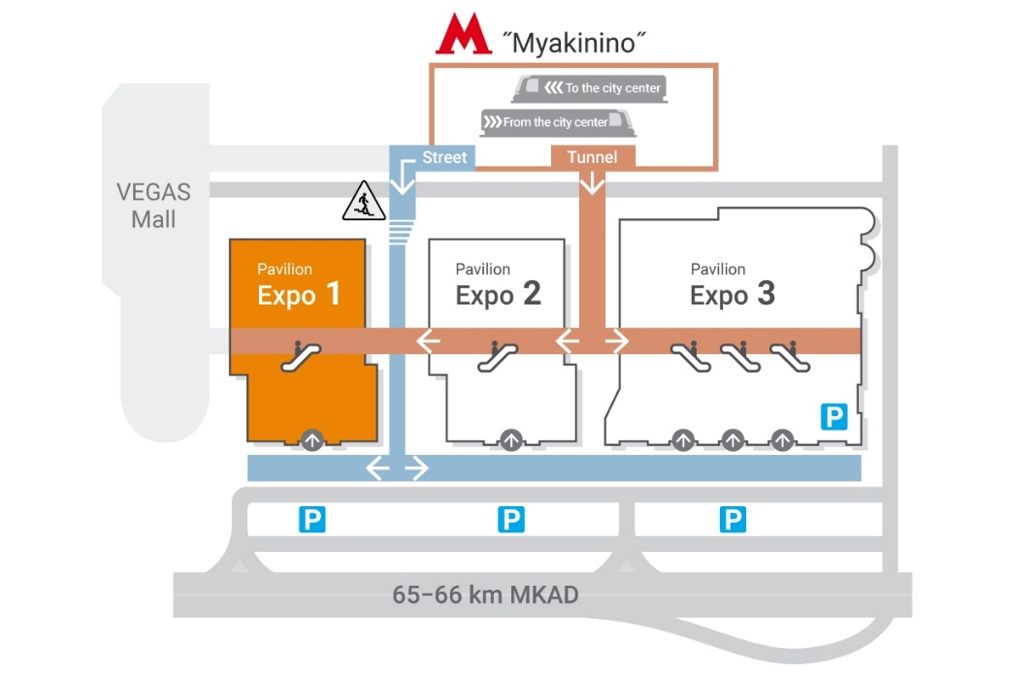

Opening hours:
28 – 30 November ………………10:00-18:00
1 December …………………….…10:00-16:00

See you at our booth no.___
Best regards,

